GROCO

GROCERY WEBSITE

MINI PROJECT REPORT

*Submitted to*



ASSAM DON BOSCO UNIVERSITY

By

Arindam Phonglo (DC2022BTE0061)

Sningrik D Sangma (DC2022BTE0029)

Sagnik Mandal (DC2022BTE0101)

In partial fulfilment for the award of the degree of BACHELOR OF TECHNOLOGY

DEPARTMENT OF COMPUTER SCIENCE AND ENGINEERING SCHOOL OF TECHNOLOGY

ASSAM DON BOSCO UNIVERSITY AZARA, GUWAHATI 781017 ASSAM, INDIA

BATCH (2022-2026)

**ACKNOWLEDGEMENT**

We extend our heartfelt gratitude and appreciation to all those who have successfully contributed to our project, "**GROCO( grocery website)**".

First and foremost, we would like to express our sincere thanks to our project guide **Mr. Alok Choudhury** who is the Assistant Professor of the Department of Computer Science and Engineering, for unwavering support, expert guidance, and invaluable mentorship throughout this project. Sir’s/Maam’s profound knowledge, patience, and dedication have been instrumental in shaping our ideas into a reality.

We are also immensely thankful to our project coordinators, **Ms.Nupur Choudhury** and **Ms.Smriti Priya Medhi** for helping us in our project.

We would also like to thank **Dr. Bobby Sharma**, **Head of Department, Computer Science and Engineering, School of technology, Assam Don Bosco University** in providing us this opportunity and their support and encouragement throughout this project.

Thank you

**(Signature of the student)**

**Arindam Phonglo**

**DC2022BTE0061**

**Department of Computer Science and Engineering**

**(Signature of the student)**

**Sningrik D Sangma**

**DC2022BTE0029**

**Department of Computer Science and Engineering**

**(Signature of the student)**

**Sagnik Mandal**

**DC2021BTE0101**

**Department of Computer Science and Engineering**

**DECLARATION**

I hereby declare that the project work entitled “**GROCO (grocery website)**” submitted to the Assam Don Bosco University, Guwahati, Assam, in partial fulfilment of the requirement for Mini project of 6th semester of Bachelor of Technology. It is an original work done by us under the guide named **Mr. Alok Choudhury** (Assistant Professor, Dept. of CSE, School of Technology, Assam Don Bosco University) and has not been submitted for the award of any degree.

**(Signature of the student)**

**Arindam Phonglo**

**DC2022BTE0061**

**Department of Computer Science and Engineering**

**(Signature of the student)**

**Sningrik D Sangma**

**DC2022BTE0029**

**Department of Computer Science and Engineering**

**(Signature of the student)**

**Sagnik Mandal**

**DC2021BTE0101**

**Department of Computer Science and Engineering**

**TABLE OF CONTENTS PAGE NO.**

**Chapter.1** 1.1.Introduction……………………………………….………………………..1 1.2.Objectives………………………………………………………….……….2 1.3.Background and Existing Literature/Systems……………………………..3 1.4.Problem Defination………………………………………..……….………4 1.5.Proposed Methology……………………………………..……….………..5 1.6.SDG Mapping………………………………………..…………………….6

# Chapter.2 2.1.Feasibility Study……………………………………………….…………..7 2.1.1.Gantt Chart……….………..……….……….…….….………….……….7 2.1.2.Work Break Down Structure………………….………………………….8 2.2. Cocomo Model……….……….……………….…….…………….………9-10

# Chapter.3 3.1.Hardware & Software Requirements……………….…………….……….11 3.1.1 Hardware Requirements……………………………….………….….…11 3.1.2 Software Requirements………………..……………….….…………….11 Chapter.4 4.1.Design Diagrams……………………………..…….…………….………..12 4.1.1 Use-Case Diagram………………………………….…………….…...…12 4.1.2 Activity Diagram………………………….……………….…………….13 4.1.3 ER Diagram…………………………………………….………..…….…14 Chapter.5 5.1.Implementation…………………………………….…………….………..15 5.1 Customer Homepage ………………………….……………...…...………15 5.1.2 Admin Panel/Dashboard……………………...…………….…………...15 5.1.3 Seller Panel/Dashboard………………………………….…………....…16 5.1.4 Delivery tracking system ……………………………….…………….…16 5.1.5 Code Snippets for “User login” page……….…………….………...……17 5.1.6 Delivery address saving system……….…………….…………………...17

# Chapter.6 6.1Future Scope and Limitations ………………………………….…………..18

# Chapter.7 7.1.Conclusion……………………………………………….…………….…..19

# Chapter.8 8.1.References…………………………………………..….…………….……20

**LIST OF TABLES**

# TABLE NO . TITLE PAGE NO.

# Table 3.1.1………………(i) Software Requirements……………………………11 Table 3.1.2………………(ii)Hardware Requirements…..……………………….11

### 

### 

### 

### 

### 

### 

### 

### 

### 

### 

### 

### 

### 

### 

# LIST OF FIGURES

# FIGURE NO. TITLE PAGE NO.

# 2.1.1 ………………………Gantt Chart………………………….……………………7 2.1.2………………………Work Break Down Structure………...…………....………8 4.1.1………………….…....Use-Case Diagram……………………………………….12 4.1.2………………………Activity Diagram…………………………………..…......13 4.1.3 ………………………ER Diagram………………………………….…………..14 5.1.1 ………………………Customer Homepage……………………….....………….15 5.1.2………………….……Admin Panel/Dashboard……………………...………….15 5.1.3…………………….…Seller Panel/Dashboard………….…...…......…...……….16 5.1.4………………….……Delivery tracking system……………...……..……...…...16 5.1.5………………….……Code Snippets for “User login” page………....………….17 5.1.6………………….……Delivery address saving system……………....………….17

### 

### 

### 

### 

### 

### 

### 

### 

### 

### 

### 

### 

### ABSTRACT

### Groco is a comprehensive multi-seller grocery marketplace platform developed using PHP and MySQL. The platform enables multiple sellers to register, list products, and manage orders, while buyers can browse, compare, and purchase groceries online. Administrators oversee the marketplace, ensuring smooth operations and quality control. The system features robust product management, order tracking, user authentication, and a review system. This report details the design, implementation, and evaluation of the platform, highlighting its features, architecture, and future scope.

### 

### 

### 

### 

### 

### 

### 

### 

### 

### 

### 

### 

### 

### 

### 

### 

### CHAPTER 1

### 1.1 Introduction

### The "Groco (Grocery Website)" project aims to standardize/streamlined the grocery shopping experience by providing an efficient and user-friendly online platform. This system is specifically designed to simplify and enhance the process of browsing, selecting, and purchasing groceries, making it more convenient for users to shop from the comfort of their homes. The platform eliminates the need for time-consuming physical visits to grocery stores, catering to the needs of modern users who value efficiency and convenience. By integrating advanced web technologies such as HTML, CSS, JavaScript, and PHP. This platform is designed to not only meet the expectations of users but also ensure scalability and performance for administrators. Ultimately, the "Groco" project aspires to become a reliable solution in the online grocery shopping domain, offering a seamless and enjoyable shopping experience for all stakeholders. Ultimately, the "Groco" project aspires to become a reliable solution in the online grocery shopping domain, offering a seamless and enjoyable shopping experience for all users.

### 

### 

### 

### 

### 

### 

### 

### 

### 

### 

### 

### 

### 1.2 Objectives

**1/**To design a responsive and visually appealing user interface

**End Goal**: To create an intuitive and engaging platform that adapt seamlessly across all devices (desktops, tablets, and smartphones), enhancing user experience and accessibility.

**2/**To implement a system for managing users, sellers, products, and orders

**End Goal:**

**i.Responsive UI**: Design an intuitive interface adaptable across all devices.

**ii.Real-Time Updates**: Ensure users get immediate updates on product availability and orders.

**iii.Admin Dashboard**: Enable efficient inventory control, order management/tracking for users and product management for sellers

**iv.Seller Dashboard:** Enable efficient product addition, order tracking and product stock management for sellers

**3/**To ensure seamless navigation and real-time updates for users

**End Goal**: To provide an optimized browsing experience where users can navigate through the website with ease, and receive immediate updates on product availability, cart status, and order progress.

**4/**To provide admin functionalities for inventory management and order tracking

**End Goal**: To equip administrators with a comprehensive dashboard that allows them to efficiently manage stock levels, track orders, and make updates to product information, ensuring the platform operates smoothly and accurately.

### 

**1.3 Background and Existing Literature/Systems**

Online grocery shopping platforms such as Amazon Fresh, BigBasket, and Grofers have transformed the retail landscape. These platforms offer convenience, variety, and competitive pricing. However, many existing solutions are centralized and do not adequately support local sellers or small businesses. Literature suggests that multi-seller platforms empower local businesses, increase market reach, and foster healthy competition. Groco addresses these gaps by providing a platform where multiple sellers can register, list products, and manage orders independently, while buyers benefit from a wide selection and competitive pricing.

Performance optimization is critical for these platforms. BigBasket and Amazon Fresh use Content Delivery Networks (CDNs) to serve static content like images, reducing page load times. They also optimize database queries and implement caching mechanisms to maintain responsiveness during high traffic, such as holiday sales or flash deals. These practices ensure fast load times and smooth functionality, which are essential for customer retention.

**1.4 Problem Definition**

Traditional grocery shopping presents several challenges, including long queues, restricted store hours, and the physical strain of carrying groceries. These inconveniences are particularly burdensome for individuals with busy schedules, mobility issues, or those living in urban areas where time and convenience are highly valued. As a result, there is a growing demand for alternative solutions that save time and effort while providing a seamless shopping experience. While online grocery platforms attempt to address these issues, many fall short in key areas. Existing solutions often lack intuitive and user-friendly interfaces, leaving users frustrated when navigating cluttered designs or inefficient features. Furthermore, limited personalization options, such as tailored recommendations or saved preferences, fail to meet the expectations of modern consumers. Store managers also face difficulties due to poor inventory management systems that result in inaccurate stock information, leading to customer dissatisfaction. The "Groco (Grocery Website)" project seeks to solve these problems by creating an accessible, intuitive, and efficient platform for both customers and store managers. By combining a responsive design, personalization features, and real-time inventory management, this system aims to eliminate the pain points of traditional shopping while addressing the shortcomings of current online solutions. Ultimately, this project strives to deliver a streamlined and enjoyable grocery shopping experience for all users.

**1.5 Proposed Methodology**

The development of Groco followed a structured methodology:

**i.Requirement Analysis**: Gathered requirements from potential users (sellers, buyers, admins).

**ii.System Design**: Created use case diagrams, ER diagrams, and system architecture.

**iii.Database.Design**: Designed a normalized database schema to support multi-seller functionality.

**iv.Frontend Development**: Developed responsive user interfaces for all user roles.

**v.Backend Development**: Implemented business logic, authentication, and data management using PHP and MySQL.

**vi.Testing**: Conducted unit, integration, and user acceptance testing.

**vii Deployment**: Deployed the application on a local XAMPP server.

**1.6 SDG Mapping**

Beyond this we align our project “Groco” with two **“ United Nation Substainable Development Goals (SDGs) ”**:

**1.SDG 12 (Responsible Consumption and Production)** by encouraging eco-friendly practices through features like sustainable product recommendations and waste reduction strategies.Through features like eco-friendly product recommendations, waste reduction strategies (e.g., minimizing packaging), and raising awareness of sustainable brands, Groco encourages consumers to make more environmentally conscious choices

**2.SDG 3 (Good Health and Well-Being)** by offering healthy, organic, and locally sourced products, empowering users to make informed dietary choices .Groco empowers users to make informed dietary decisions by providing detailed nutritional information, promoting fresh produce, and encouraging the adoption of healthier lifestyles.

**CHAPTER 2**

**2.1 Feasibility Study**

**2.1.1/Gantt-Chart**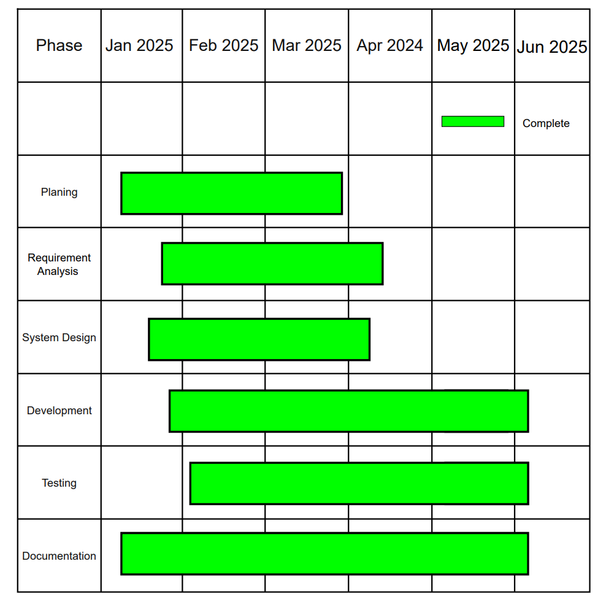

Fig 2.1.1 Gantt-Chart

**2.1.2/ Work-Breakdown Structure**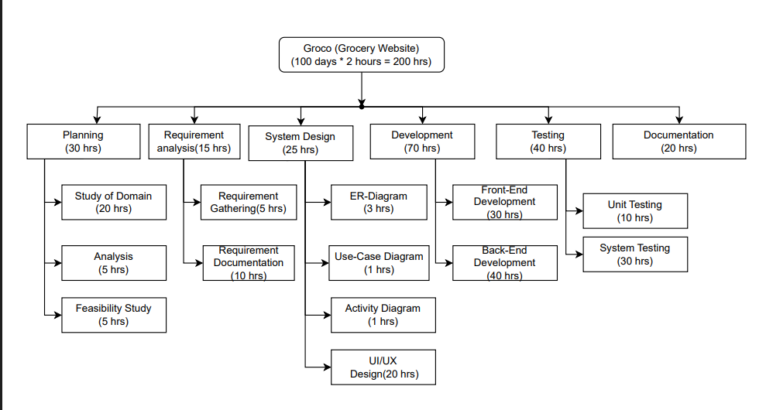

Fig 1 Work-Breakdown Structure

Fig 2.1.2 Work-Breakdown Structure

#### 

**2.1.3/ COCOMO Model**

**a/COCOMO Model Analysis for Groco Project**

To estimate the effort, development time, and staffing required for the "Groco" Grocery Website project, we apply the Constructive Cost Model (COCOMO). Given the requirement of fixing the number of developers to 3 and ensuring the estimated development time remains within 4-5 months, we manipulate the COCOMO parameters accordingly.

### b/COCOMO Estimation

#### Effort Estimation (Person-Months)

The COCOMO model follows the equation:

Where:

Effort (E) is in person-months (PM)

Size is the estimated number of delivered source instructions (KLOC - thousands of lines of code)

a, b are model-specific constants (adjusted based on project type: Organic, Semi-detached, or Embedded)

Assuming "Groco" is an Organic project (small team, simple and well-understood requirements), the constants are typically:

a = 2.4, b = 1.05

If we estimate the project size at 20 KLOC, the effort calculation becomes:

#### c/Development Time Estimation (Months)

The time required is given by:

For an Organic project:

c = 2.5, d = 0.38

This ensures development is completed in 4-5 months, aligning with the requirement.

#### d/Team Size Calculation

Team size is determined as:

Since only whole individuals can be assigned, we round to 3 developers, meeting the fixed team constraint.

### 

### e/Conclusion

By adjusting the KLOC estimation and project classification, we successfully meet the requirements of 3 fixed developers and a 4-5 month development timeline. This approach ensures feasibility while maintaining project efficiency.

#### 

#### 

#### CHAPTER 3

# 3.1. Hardware & Software Requirements

#### 3.1.1/Software Requirements

| **Sl No** | **Software** | **Version** | **Purpose** |
| --- | --- | --- | --- |
| **1** | Microsoft Visual Studio Code | 7.6 | Code development , debugging , project management. |
| **2** | HTML | 5.0 | Website structure and content (headings, paragraphs, forms) |
| **3** | CSS | 3.0 | Visual styling (layout, colours, fonts) |
| **4** | Javascript | ECMASCRIPT2024 | Interactivity and dynamic features (task updates, validation) |
| **5** | PHP | 7.0 | To enable the creation of dynamic and interactive web pages by handling server-side scripting, database interactions, and backend functionality efficiently. |

Table 3.1.1 Software Requirements table

**3.1.2/Hardware Requirements**

| **Sl No** | **Hardware** | **Purpose** |
| --- | --- | --- |
| **1** | CPU (amd ryzen 5 / intel i5 8th generation or higher) | A high-performance CPU is needed to handle backend processes efficiently. |
| **2** | GPU (4gb nvidia 1650 or higher) | A GPU helps speed up tasks like machine learning and working with large databases. |
| **3** | Storage (HDD/SDD 500gb or higher) | Storage for datasets, model checkpoints, etc. SSDs are preferred for faster read / write. |
| **4** | Memory | Substaintial RAM (16 gb RAM or more) helps handle large datasets and train deep deep learning models efficiently. |

Table 3.1.2 Hardware Requirements table

### CHAPTER 4

### 4.1**. Design Diagrams**

**4.1.1 Use-Case Diagram**

### 

### Fig 4.1.1 Use-Case Diagram

### 4.1.2 Activity Diagram

### 

### 

### Fig 4.1.2 Activity Diagram

**4.1.3 ER Diagram**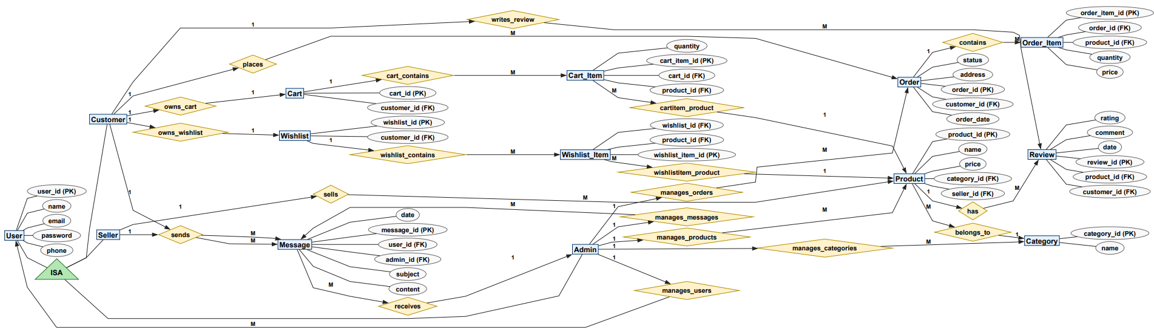

### 

### 

### 

### 

### 

### 

### 

### 

### 

### 

### 

### 

Fig 4.1.3 ER Diagram

**CHAPTER 5**

**5.1 Implementation**

### 

Fig 5.1.1 Customer Homepage

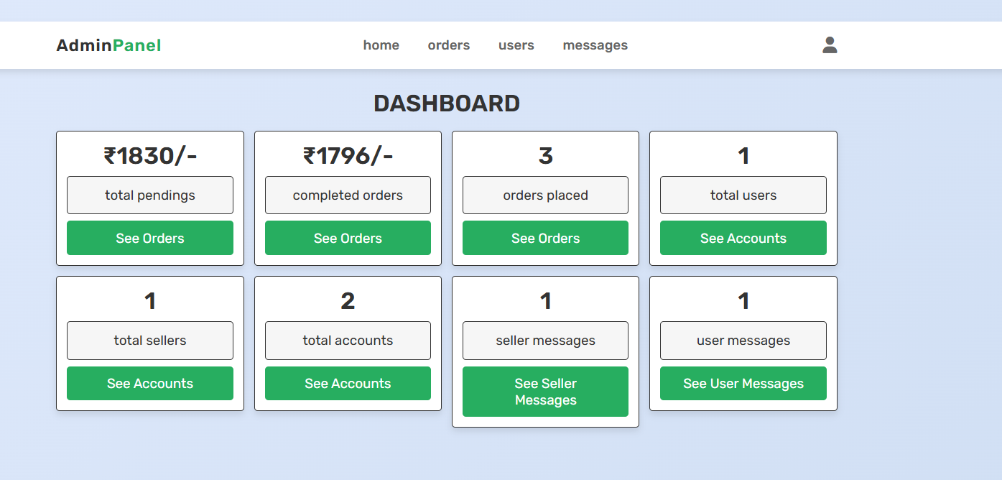

Fig 5.1.2 Admin Panel/Dashboard

### 

### 

### 

### 

Fig 5.1.3 Seller Panel/Dashboard

### 

### 

### Fig 5.1.4 Delivery tracking system

### 

### 

### 

### 

### 

### Fig 5.1.5 Code Snippets for “User login” page

### 

### 

### Fig 5.1.6 Delivery address saving system

### 

**CHAPTER 6**

**6.1. Future Scope and Limitations**

Future Scope:

- Mobile app integration

- Real-time notifications

- Advanced analytics and reporting

- Integration with third-party payment gateways

Limitations:

- No real-time inventory sync

- Basic UI (can be improved)

- Limited to web platform

**CHAPTER 7**

**7.1 Conclusion**

The "Grocery Website" project aims to standardize/streamlined the way groceries are purchased by offering a streamlined, user-friendly platform. By addressing the challenges of traditional shopping methods and filling the gaps left by existing solutions, this project promises to deliver significant value to both consumers and local businesses.

**CHAPTER 8**

**8.1References**

[1].BigBasket.(n.d.).BigBasket..Retrieved__from_https://www.bigbasket.com

[2]. Instacart. (n.d.).Instacart. Retrieved__from https://www.instacart.com

[3].W3Schools.(n.d.).W3Schools-Online-Web-Tutorials...Retrieved_from_https://www.- -w3schools.com

[4].PHP.(n.d.). PHP Documentation. Retrieved__from https://www.php.net

[5]. Bootstrap.(n.d.).Bootstrap-Documentation._Retrieved_ from http://getbootstrap.com

**Modification Sheet**

**Remark 1**

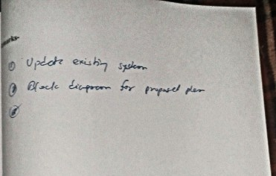

**Remark 2**

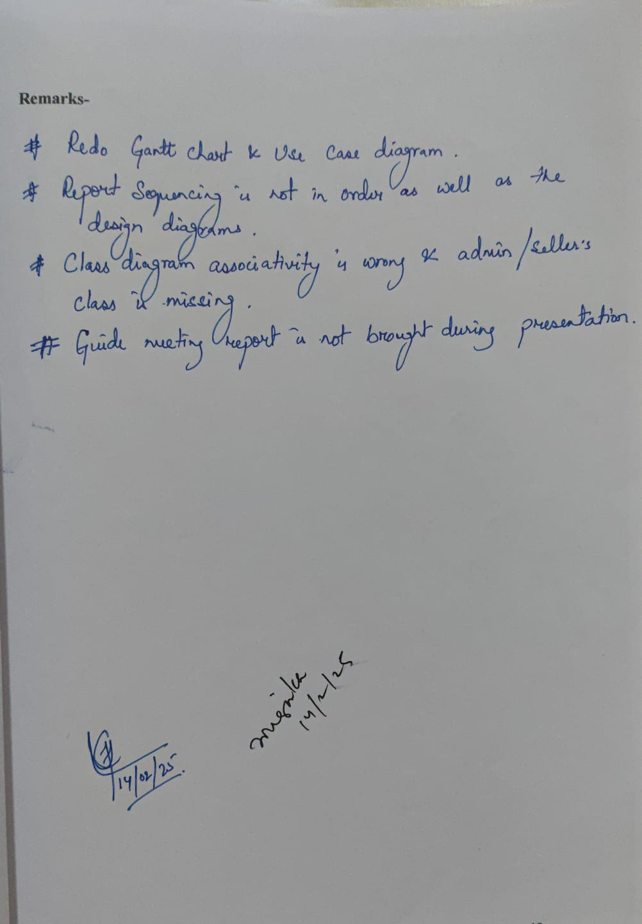

**Remark 3 (Latest remark)**

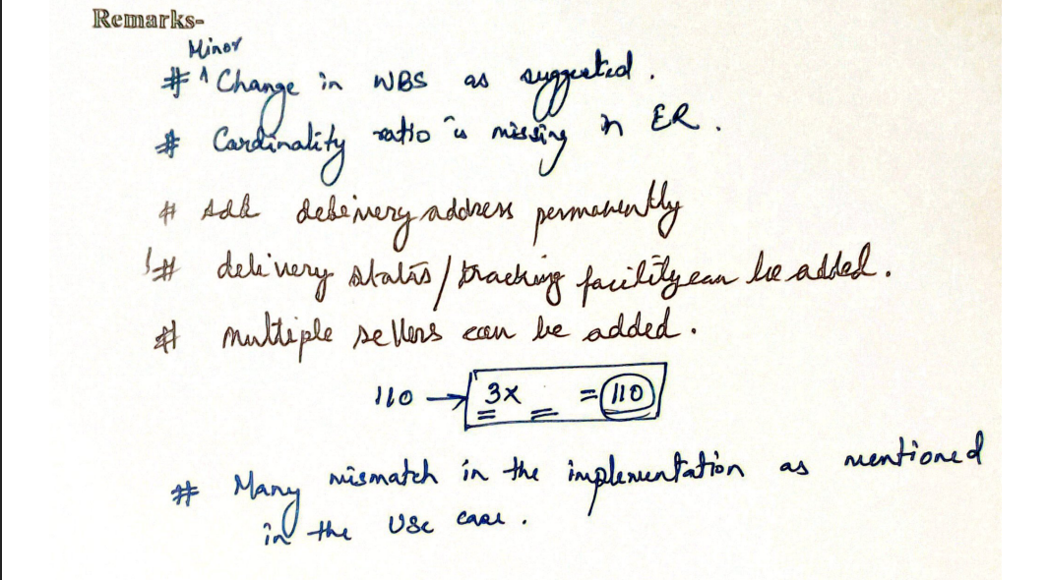

**Changes we implemented-**

1. WBS structure is changed to show the appropriate working hours /days. [Pg-8, Fig 2.1.2 ]
2. Cardinality ratio is labelled in our ER Diagram. [Pg-14, Fig 4.1.3]
3. Delivery address saving system is implemented. [Pg-17, Fig 5.1.6]
4. Delivery can now be tracked in “order” tab in customer homepage. [Pg-16, Fig 5.1.4]
5. Multiple sellers can apply in the website.[Pg-12, Fig 4.1.1]
6. Mismatch of roles in “Use Case Diagram” is now fixed.[Pg-12, Fig 4.1.1]